

Mediation Documents
Agreement to Mediate and Confidentiality Form 2
Mediator Statement 4
Conflict Path 5
SONAR Process 6
Facilitation Training Outline 7
Investigation Results 8
Inspiration Statement 12
Working Plan Settlement Agreement 13
Invoice 16

Agreement to Mediate and Confidentiality Form

Fowler Mediation

This is an Agreement to enter into mediation with the intent of resolving workplace issues.

The participants and the mediator understand and agree as follows:

- Nature of Mediation

The participants hereby appoint and retain Clare Fowler as mediator for their negotiations. The participants understand that mediation is an agreement-reaching process in which the mediator assists participants to reach agreement in a collaborative, consensual and informed manner. It is understood that the mediator has no power to decide disputed issues for the participants. The participants understand that the mediator's objective is to facilitate the participants themselves reaching their best agreement. The participants also understand that the mediator has an obligation to work on behalf of all participants and that the mediator cannot render individual legal advice to any participant and will not render therapy nor arbitrate within the mediation.

The participants also understand that mediation is not a substitute for independent legal advice. The participants are encouraged to secure independent legal advice throughout the mediation process and are strongly advised to obtain independent legal review of any formal mediated Agreement before signing that Agreement. The mediator may come to require one or both participants to have their agreement reviewed by legal counsel to ensure that a participant is reaching a reasonably informed agreement. The participants agree that, even if the mediator is an attorney, the mediator will not serve any participant, nor all participants, as legal counsel, nor render individual legal advice in this mediation.

- Scope of Mediation/Good Faith

The participants understand that it is for them, with the mediator's concurrence, to determine the scope of the mediation and this will be accomplished early in the mediation process.

- Mediation is Voluntary

All participants here state their good faith intention to complete their mediation by an agreement. It is, however, understood that any participant may withdraw from or suspend the mediation process at any time, for any reason or no reason.

- Confidentiality

It is understood between the participants and the mediator that all mediation communications will be strictly confidential. Mediation discussions, be they in person, on the phone, by email, text or by any other communication modality, any draft resolutions and any unsigned mediated Agreements shall not be admissible in any court, administrative or other contested proceeding. Only a mediated Agreement signed by any participants may be so admissible. The participants further agree to not call the mediator to testify concerning the mediation nor to provide any materials from the mediation in any court or other contested proceeding between the participants. The mediation is considered by the participants and the mediator as settlement negotiations. All participants also understand and agree that the mediator may have private caucus meetings and discussions with any individual participant, in which case all such meetings and discussions shall be confidential between the mediator and the caucusing participant.

- Mediator Impartiality and Neutrality

The participants understand that the mediator must remain impartial throughout and after the mediation process. Thus, the mediator will not champion the interests of any participant over another in the mediation nor in any court or other proceeding. The mediator is to be so “impartial” as to participant and “neutral” as to the results of the mediation. The mediator will seek to affirmatively reveal any operative biases and will disclose any and all prior contacts with the participants and their legal counsel.

- Mediation Fees

The participants and the mediator agree that the fee for the mediator shall be $____ per hour for time spent with the participants and for time required to study documents, research issues, correspond, telephone call, prepare draft and final Agreements and do such other things as may be reasonably necessary to facilitate the participants reaching full Agreement.

- Non-Binding and Informal
Parties understand this is a non-binding and informal process. Parties are not bound by any suggestion the mediator or participants make. A contract signed by both parties, however, is admissible in court. The parties also understand that this is an informal process. By going through mediation, the parties do not waive their right to a formal process.

DATED this __ day of ____, 20

Mediator Statement

My name is Clare Fowler and I am your mediator. Thank you for participating in mediation.
Mediation is a process where a neutral person guides you through a conversation to hopefully reach an agreement.
Mediation is a voluntary process. You are here of your own free will because you are taking control to make this conflict better.
Mediation is confidential. That means when we are done mediating, I will not and by law cannot discuss the details of this mediation. It means that you are held to those same rules.
Mediation assumes you are acting in good faith. You are telling the truth, including all pertinent information, and you are negotiating to try to reach an agreement.
Mediation is a neutral process, meaning I do not take sides. I try to listen to both sides and advocate for both of your interests, being omnipartial.
Mediation is a party-driven process—I have a template I like to follow, but if you need to go back and review something or move ahead then you both are the boss.
Mediation is an informal process, meaning we are currently resolving a dispute outside of the court’s eye.
Mediation is a non-binding process. If you reach an agreement today, then that signed agreement will be binding in a court of law.
Mediation means that you are open to compromise and that you agree to our ground rules.
Mediation is a 5 step process: SONAR. It begins with my Statement, then your Opening introduction, then we can Negotiate together, and then hopefully reach an Agreement, and decide on a good Resolution.

Signed______________
Dated______

Conflict Path

If it is helpful, we can examine what was the Entrance to the conflict and what made it Escalate. This can often help us find an appropriate Exit.



SONAR Process
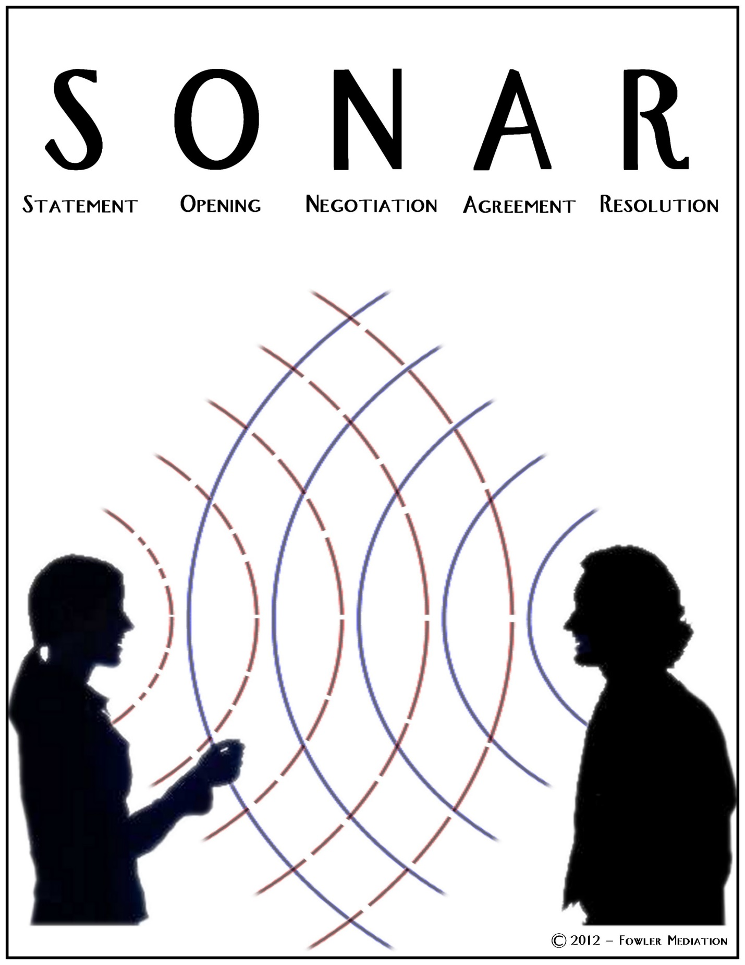

Facilitation Training Outline

Pre-Meeting:
Determine purpose
Determine objectives
Select participants
Define expectations (presentations?) for participants
Take all of above and create agenda with rough time schedule
Communicate agenda, 2 weeks in advance if possible, to all invited, open to edits
Communicate final agenda 1 week in advance

During Meeting:
Cover groundrules (clipboarding policy)
Review agenda—(any necessary changes? If not, everyone in agreement?)
Assign note-taker (write down big ideas, legibly, don’t rank or assign names, use speaker’s words or detoxified words)
Be neutral
Acknowledge every idea
Stick to schedule
Request feedback from every key participant
Summarize, set next meeting if necessary

Post-Meeting:
Send summary to all participants as well as all affected within 2 business days
Thank everyone for attending
Send weekly follow-ups that address meeting objectives

Investigation Results Sample

Findings of Age Retaliation and Age Discrimination Investigation
_______________________________________________________________________________

Complainant:

Bob Sanders

Investigator:

Clare Fowler (contact and bio information available at www.ClareFowler.com) was contacted to investigate the claim of age retaliation and age discrimination.

Organizations Involved:
Microsystems Engineering, Inc. (MSEI)

Complaint:

Bob Sanders alleged that the Performance Improvement Plan is retaliatory and undeserved.

Investigation Findings:

There is no evidence of retaliation or age discrimination.

Summary of Complaint:

Bob Sanders sent an email to Company ABC (Company ABC is supported by MSEI’s IT functions) describing security concerns. His concerns were that the organization was not in compliance with necessary security protocols, and that this left the organization vulnerable to damage.

During the delivery of Bob Sanders’s 2013 performance review, he received notice that he was being put on a Performance Improvement Plan (PIP). MSEI told Bob that the PIP was in response to three years of substandard Performance Reviews.

Bob alleged that the PIP was in response to his filing a complaint. He stated that he was concerned that MSEI was looking for a reason to move him out of his current position and quiet his concerns. He believed he was being ignored and having his concerns suppressed instead of having his concerns taken seriously. He believed that MSEI was dismissive of his concerns due to his age. Had he been a different age, he alleges MSEI would have given his concerns more merit instead of responding with a PIP. Thus, he believed the PIP was in retaliation to his complaint and his age, and not indicative of poor performance.

Findings of Age Retaliation and Age Discrimination Investigation
_______________________________________________________________________________

Action Taken:

Investigation initiated May 11, 2014.

Investigation completed May 21, 2014.

Company ABC contacted Clare Fowler to investigate the allegation of age retaliation and age discrimination. Clare Fowler spoke with Bob Sanders multiple times on the phone and via email, and also with Denis Krauss (Bob Sanders’s supervisor). Clare Fowler also reviewed supporting documents submitted by Company ABC and Bob Sanders.

Documents Reviewed:

2010 Performance Review of Bob Sanders
2011 Performance Review of Bob Sanders
2012 Performance Review of Bob Sanders
2013 Performance Review of Bob Sanders
Draft: Performance Improvement Plan
Job Description and Plan Spreadsheet by Bob Sanders
Proposal for a Security and Compliance Program by Bob Sanders
Email: May 7, 2014, from Bob Sanders to Sven Rasmussen, responding to the PIP
Email: May 9, 2014, from Bob Sanders to Sven Rasmussen, stating retaliation concerns

Findings:

The investigator determined that there are three separate, unrelated issues. The first issue is the security and compliance concern. The second issue is the complaint of retaliation and age discrimination. The third issue is Bob Sanders’s work performance.

1) The investigator was not hired to investigate the security and compliance concern and thus cannot make any determination into its validity. The investigator makes note that this is a separate concern, unrelated to the validity of the Performance Improvement Plan.

2) There is no evidence of retaliation or age discrimination. Multiple comments had been made in Bob Sanders’s presence that could be construed as teasing based on age. It appears that these comments were made lightheartedly in a joking manner, and not as an actual indicator of discrimination or poor performance. Bob Sanders was not discriminated against due to his age. Some comments made were not in good taste, but were not severe enough to create a hostile work environment.

There was a comment about physical appearance that was inappropriate for a supervisor to say to an employee, even though it was posted with the intention of good-natured joking on a social media site and not in the workplace. Bob Sanders made his supervisor aware that he did not appreciate these comments and it appears that these comments have stopped.

3) The Performance Improvement Plan (PIP) is warranted. Upon investigation, the compliance complaint, the concerns of retaliation and/or age discrimination, and the PIP are not related. The compliance complaint is a separate issue, worthy of a separate investigation. The PIP is a direct result of three years of poor performance. Quality, focus, and initiative concerns were raised in the 2011 performance review. These same concerns were documented in the 2012 and 2013 reviews. After three performance reviews that documented similar concerns, a more serious approach to improving performance is expected. It is a logical response from the company, and should also be expected by an employee.

Additional Notes:

Bob Sanders is someone who is passionate about his work and takes it very seriously. He has put many years into the company, and expressed to the investigator a desire to put in many more. Trust and performance issues will need to be addressed. Company ABC will need to decide exactly how to address and monitor those issues, and Bob Sanders will need to decide how he wants to respond. It is the investigator’s opinion that if he addresses the quality, focus, and initiative concerns raised in the performance reviews, he can continue to be a valuable asset to the company.



Inspiration Statement
I have the skills to do this job well

I want the public to enjoy the outdoors

Work together as a team to make that possible
Work with Integrity
Hold Each other accountable
I have the skills to do my part well
The Leadership Team will lead our office with integrity. We will be good stewards of public lands, public resources, the budget, and our employees’ time and skills. We will listen to the employees’ concerns, make improvements where possible, and support employees desire to be effective in their job.

Agreement as of August 19, 2016

Working Plan Settlement Agreement

This Settlement Agreement ( hereinafter “Agreement”) is made and entered into voluntarily between Carol Fowler and Whitney Abbot, sample clients.
Parties may request to reopen the mediation process if any party does not carry out his or her responsibilities in good faith.
All Parties agree to the following:

Communication Policy
Written communication, such as email, is preferable at this early stage. When either party has a concern or a need for clarification, it should be communicated via email. The goal of this plan is to encourage verbal communication and trust.

- An initial email should be sent from Whitney to Carol clarifying her plans going forward regarding her supervisory role.
- Both parties agree that they need a more effective communication strategy. This is for the good of the organization, as well as their own well-being. Both parties agree to work toward that goal and operate in good faith—taking care to speak in a way that encourages communication and trust and to address potential miscommunications early.
- Currently, Whitney sends Carol a weekly summary of what she has been working on that week. Whitney agrees to change this summary to also include weekly expectations. This will allow Carol to reply back with any questions, before the work has occurred.
- Whitney will continue to cc Carol even if her supervisor changes. Carol agrees to reply back quickly if she has any concerns or need for clarifications.
- Carol and Whitney agree to begin meeting face-to-face. They will begin meeting once per week, probably on Wednesday morning but this time can change as their schedules demand. Initially these meetings will be short, approximately ten minutes. Ideally, as Carol and Whitney become more comfortable communicating verbally the length of these meetings will increase. The purpose of these meetings is to discuss anything not covered in the weekly summary/expectation email, or review anything that needed additional clarification. They agree that this meeting will include positive feedback and validation of professional work, not just statement of concerns.
- When clarification is necessary, both agree to ask questions and not just make accusations.
- Both agree that over the next four weeks during the face-to-face meeting, they will focus on why questions. These questions will allow them to address concerns quickly--and then let them go. The purpose is to begin to understand where the other person is coming from, to build trust and each other, and to not allow there to be lingering concerns. Rather, they will focus on understanding and resolution of those concerns.
- There will be an increase in email coming from the management, to the entire staff. The purpose of the emails will be to develop relationships and increase communication. The content of the emails will be things that might interest the staff, such as birthdays, events, or procedural changes.
- After the monthly staff meeting, there will be a staff-wide email containing a summary of the meeting.
- There will be a four-week check in, around May 20th, likely instigated by the mediator, to ensure communication is improving. At this time the purpose of the weekly review and the weekly face-to-face meeting will be reviewed to determine if any of the logistics or length should be changed.

Job description

- For the next six months, Whitney will step down from her supervisory duties. During this time, Sam will supervise their parts department. This also means that during this time Sam will be present during the weekly between Whitney and Carol. After these six-months, Carol will initiate a conversation around October 20th, to check in and see if Whitney would like to permanently relinquish her supervisory duties, or if she would like to step back into that role.
- In order to support Sam as the supervisor, Whitney will be very clear about the information, guidance, and direction that she and the entire parts department team need from him. She will be responsible to ensure they are getting the information they need. When she is not getting exactly that information, she will let him know immediately. She will also let him know the timeframe in which she needs that information. She will focus on this effort for the next four weeks to shape expectations with Sam from the beginning.

1. Written Resolution Agreements. Written agreements may not violate applicable law, rule, regulation, collective bargaining agreements, or written policies of the Department of the Fake Company. If technical, legal or administrative review reveals such a violation in a proposed agreement between or among the parties, the Conflict Resolution Specialist shall establish a reasonable time for the parties to reach a viable alternative resolution

2. This agreement does not constitute an admission by either party that there has been a violation of any law or regulation.

3. The terms of this Agreement will not establish any precedent nor will the Agreement be used as a basis by the parties, Department of Fake Company, or any representative organization to seek or justify similar terms in any subsequent case.

4. This Agreement constitutes the complete understanding between the parties. No other promises or agreements shall be binding unless in writing and signed by both parties.

5. This Agreement may be used as evidence in a subsequent proceeding in which either of the parties alleges a breach of the Agreement.

6. Signature on this document is voluntary and is done without coercion, duress, or pressure on the part of either party.

7. This settlement agreement is between the parties and remains confidential. This agreement is
shown to others, by agreement between the parties, only on a need-to-know basis to enforce the agreement.

Party A signature & date: ________________________________________________

Party B signature & date: ________________________________________________

Invoice

Mediation Summary

Date of Meeting: May 28, 2016
Time of Conversation: 2:-4:15
Rate: $150/hr.
For meeting, phone prep, issues discussion, clarifying emails, findings review, and document creation.

Time | Rate | Total
2.25 hours | $150/hr | $350.00 Mediation
 |  | $350.00 Total balance due

Bill to:
Client
Thank you for prompt payment to:
Fowler Mediation
Thank you,
Clare Fowler
Clare@Mediate.com

